Name: Karan R
Domain: Data Analyst
Project: Power Bi Snapdeal Project
Task 1: To show how discount varies with Price range (two continuous variable). Which visual would best show the relationship: histogram, scatter plot, line chart or heatmap?
Answer:
A scatter plot is the most appropriate visual to show how Discount varies with Price range.
Explanation:
Since, Both Price and Discount are continuous numerical values. A scatter plot is specifically designed to analyze the relationship between two continuous variables by plotting individual data points on a two-dimensional plane. Each point represents a product, with Price on the X-axis and discount on the Y-axis.
This visualization makes it easy to identify patterns, correlations, clusters, and outliers such as whether higher-priced products tend to offer higher discounts or whether discounts are independent of price.
Other visuals are less suitable because a histogram shows the distribution of a single variable, a line chart is best for time-based trends, and heatmap requires aggregation that can hide individual data relationships. Therefore, a scatterplot provides the clearest and most accurate representation between price and discount.
Visual representation: 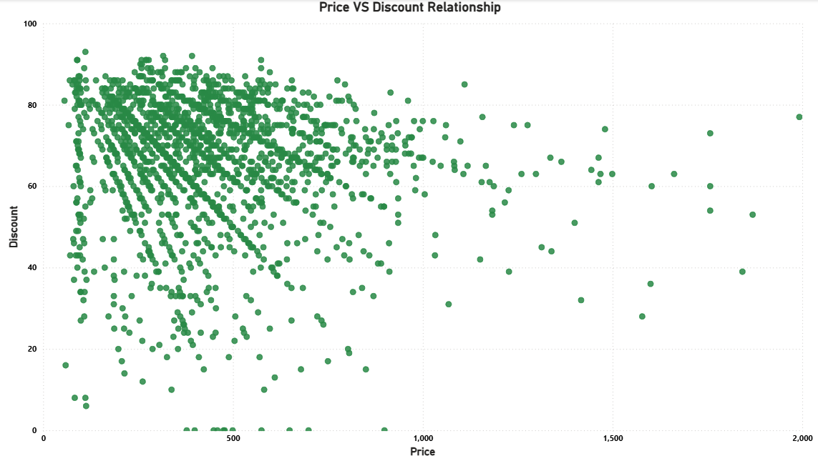

Here in this image we can see that how a scatter plot was used to visualize the relationship between Price and Discount, as both are continuous numerical variables. Each point represents an individual product, allowing clear observation of how discounts are distributed across different price ranges. The chart shows that discounts are spread across all price levels, indicating no strong linear relationship Price and discount.
Insight:
From the chart, it is observed that discounts are spread across all price levels, indicating that higher discounts are not strictly dependent on higher prices. There is no strong linear relationship between price and discount.

